CHAPTER 7: Elements, compounds and mixtures
Worksheet 7.4

The periodic table — atomic structure
Student: Class:

As the early scientists discovered more and more elements, it became more important that they agreed on names for the elements. Each element was given a name and a symbol. During their experiments, the scientists also found that some of the elements had things in common. Because of this they decided to organise the elements into groups.
The person who finally worked out a system for sorting the elements into groups was a Russian scientist called Dmitri Mendeleev. His system is called the periodic table and a modern version is used by scientists today. A small portion of the periodic table is shown below.
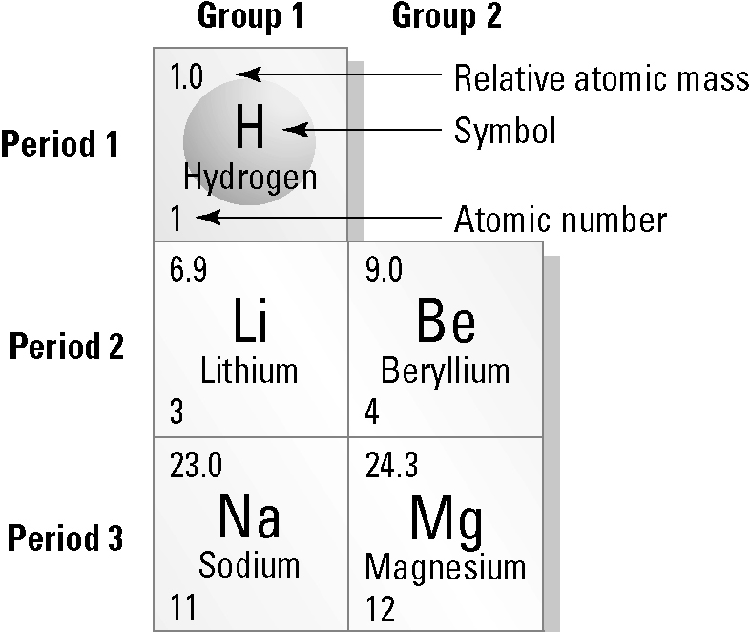 | The atomic number of an element is the number of protons present in each atom. For example, all hydrogen atoms have only one proton inside the nucleus, so the atomic number of hydrogen is 1.  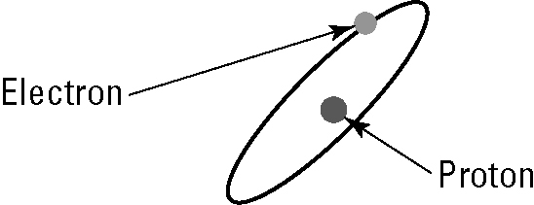  - A simplified diagram of a hydrogen atom
Atoms are electrically neutral; that is, the number of protons in an atom is the same as the number of electrons. The atomic mass of an atom is the sum of the number of protons and neutrons in
the atom.
Complete the following table, using the information provided above. You might also like to
review the structure of an atom in your textbook.
Element | Symbol | Atomic number | Atomic mass | Number of protons | Number of electrons | Number of neutrons
Hydrogen
Lithium
Beryllium
Sodium
Magnesium

